Division of Systems and Control   
Department of Electrical Engineering   
Chalmers University of Technology

**Project proposal for SSY226:**

**Greenhouse lighting control by chlorophyll fluorescence**

**Background**

Traditional greenhouse lighting is based on high pressure sodium lamps (HPS), which are more or less of the same type as highway lights. They have a high efficiency, but a spectrum not well suited for photosynthesis. Today, LED based greenhouse lights have higher efficiency and by combining LEDs of different colors they can be made to have a close to optimal spectrum for the plants. They have also come down in price to be able to compete with the HPS lamps. Interestingly, the introduction of LEDs also enables control opportunities that were not possible with the traditional lamps that could only be switched on and off, and with long time intervals. LED lamps can be designed such that the different colors can be dimmed individually, which means that both spectrum and intensity can be adjusted, and at a very high bandwidth.



What most people do not know is that plants emit light, i.e. fluoresce. We can generally not see this fluorescence because it is weak and most of it is outside the visible spectrum for humans. However, we can measure this light and because it is closely interlinked with the photosynthesis it contains information about the status of the plant.

The Automatic Control group is actively conducting research in this area to explore the possibilities of feedback lighting control based on biological information extracted from the dynamic response of the plants to changes in incident light. This way the energy efficiency and production can potentially be increased by tenths of percent. Considering that the electricity consumption in the European greenhouses is in the same order as the total electricity consumption in Sweden, this can have a tremendous environmental and economic impact.

In our research we have seen that transfer functions that has been identified from data exhibit clear changes when the plants become stressed by too much light. In particular it seems as if the phase shift at a given frequency can be a promising feedback signal to use for optimizing the lighting.

In the cellar of the E-building we have a small growth cabinet where we can control the light emitted from each LED color, measure the light with a spectrometer and also with a recently developed fluorescence sensor. The lamps, spectrometer and fluorescence sensor are all communicating with Matlab. A commercial fluorescence sensor is very expensive and is not really realistic to equip every lamp with. The developed sensor, however, is based on a cheap photo diode and an optical filter, and is a very cheap alternative that may suffice. The existing version is a prototype, and to get it to work properly some additional signal processing is needed.

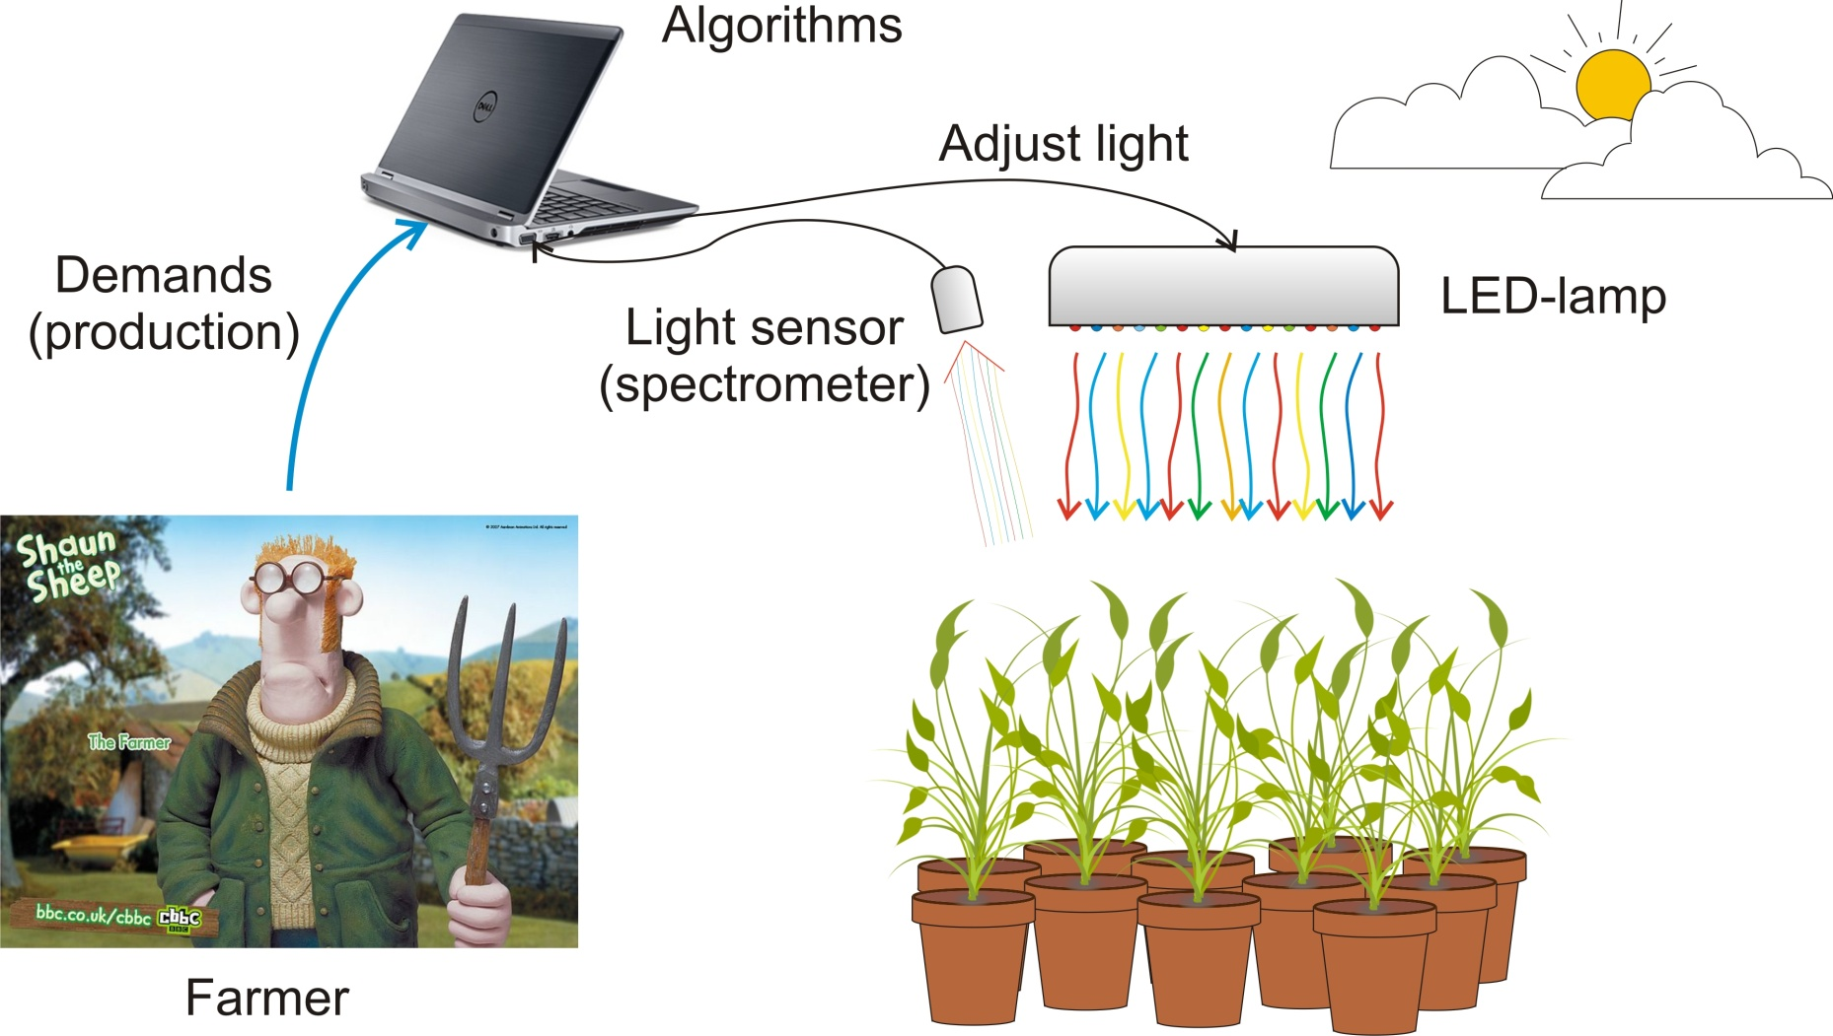

**Problem description**

This project is aiming at a completion of the setup such that it becomes extremely easy to carry out experiments collecting input signals (changes in powers to the diodes) and output signals (fluorescence) as well as demonstration of different choices of control methods and a robustness analysis. In particular, a controller is to be designed that maintains a specified phase shift between a small sinusoidal change in one of the LED colors to the measured fluorescence at a specified frequency. A tentative plan, in addition to a literature review, would be

* Make the fluorescence measurements stable and well integrated with the system setup, and determine a suitable filtering of the signal.
* The system is nonlinear from power to emitted light. Therefore, a nonlinear mapping must be implemented to achieve a sinusoidal light excitation.
* The plants also behave nonlinearly, but since the input excitation amplitude will be low the variation in the fluorescence signal will be approximately sinusoidal. Determine the best way to estimate the phase shift, in spite of the nonlinearity and measurement noise.
* System identification can be used to identify a transfer function from variations in LED power to variations in fluorescence. Either new experiments are made for this purpose or existing models/data can be used. Based on the model a feedback controller locking the phase shift is designed and implemented in Matlab/Simulink.
* Analyze the robustness of the design in simulation.
* Test the developed signal processing and control design on plants.

**Number of students: 3**

**Prerequisites.** Knowledge in the following topics: modeling and simulation of mechatronics systems, multivariable control, basics of computer programming and experience of Matlab and Simulink.

**Contact:** Torsten Wik ([tw@chalmers.se](mailto:tw@chalmers.se)), Automatic Control



UN has announced that a 60% increase in global food production by 2050 is needed to feed the world’s growing population. One of the multiple challenges is to adopt more sustainable and efficient production methods to increase the yields. In greenhouse production there are significant yield losses caused by plant stress factors. It includes abiotic stress factors such as nutrient deficiency and too much light, as well as biotic stress factors such as pests and diseases. Plant health monitoring, for early detection and identification of plant stress, is critical, so that appropriate control decisions can be made in time. Today, monitoring requires frequent and precise observations of plants by the greenhouse staff. It is labor-intensive and error-prone due to human intervention, and often not compatible with production constraints. In an on-going research project we are developing a method for automatic plant health monitoring in greenhouses based on proximal remote sensing of chlorophyll fluorescence. The research also includes strategies for adjusting the light intensity and spectral content according to the status of the plants, using LED lamps.

Green plants are fluorescent, in the sense that they absorb light of wavelengths between 400 and 700 nm, and then re-emit a small part of this energy as light of wavelengths